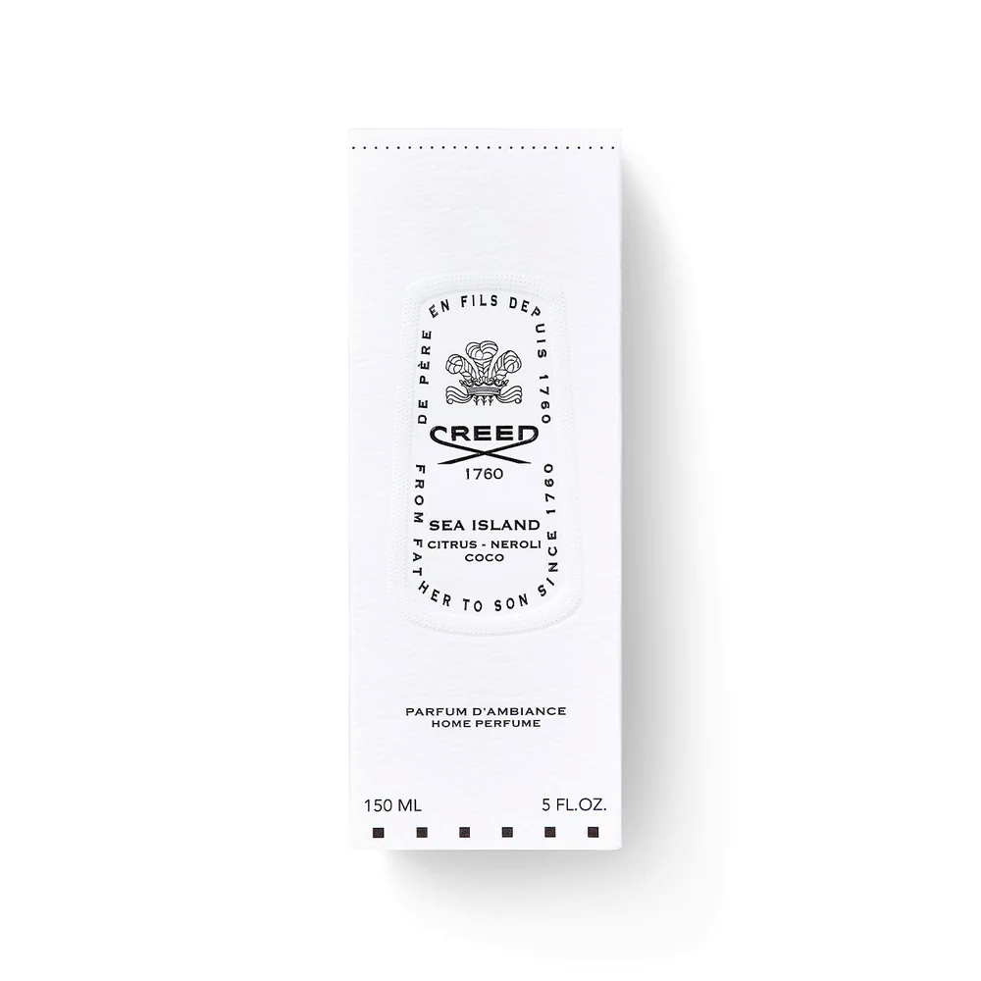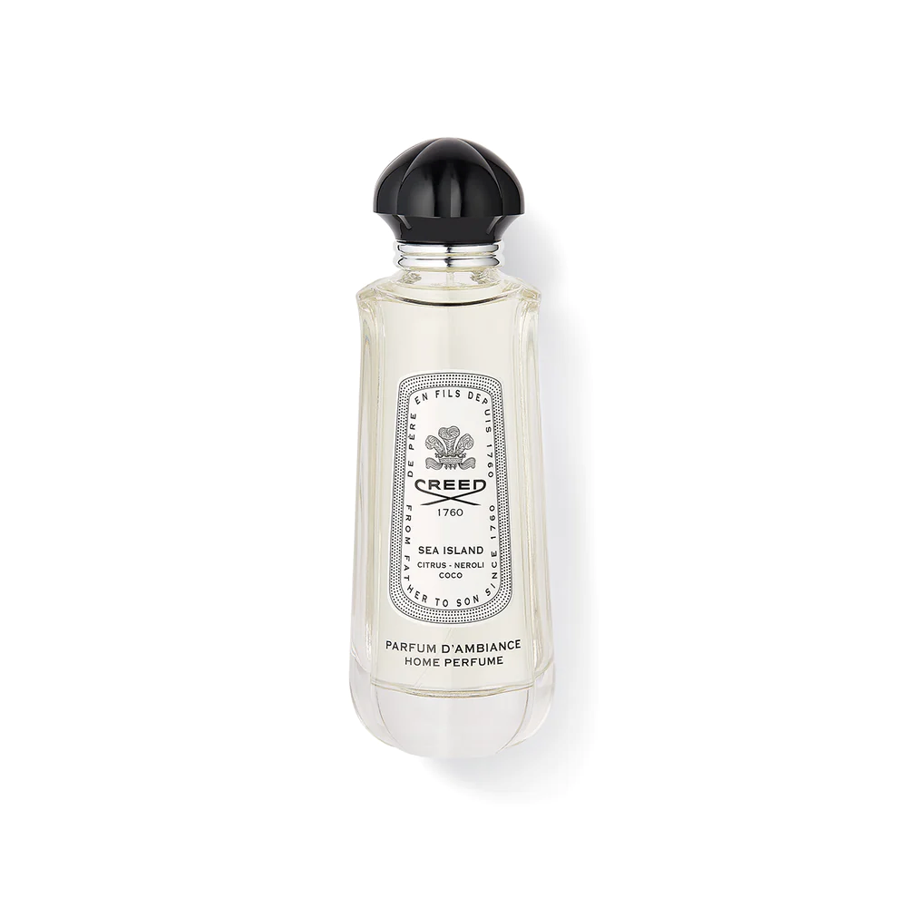

SEA ISLAND HOME SPRAY

**$95.00**

Tax Included.

Spray 100 mL

IN STOCK

### Product Details

Inspired by the memories of maritime adventures enjoyed by Olivier Creed and his young family, Sea Island exudes a misty freshness.

A blend of citrus and neroli are layered over a soft coconut note, resulting in a rejuvenating home perfume that elevates the mood in any room.